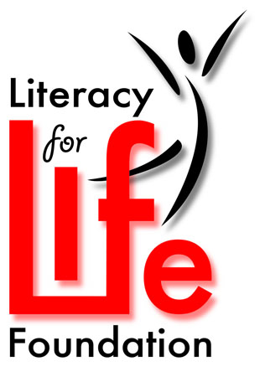
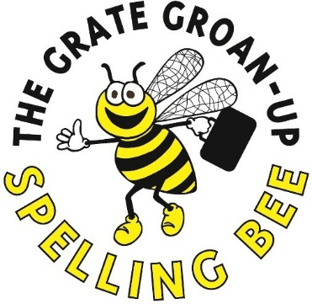

7th Annual Grate Groan-Up Spelling Bee
September 28th, 2019

TEAM REGISTRATION FORM
Please submit completed form to info@litforlife.com or fax to 403.601.2389

YES ____________________________________________________ will participate!
(Team Name)

Team Information
NAME
EMAIL

We encourage each team to line up alternates to ensure a full team at the BEE!
If a team plans to use a “Friend” they must be registered at the registration desk at the Bee by 1:00 pm
Check off if you have read and agree to the registration expectations- found on Page 2 ☐

SHOW US YOUR TEAM SPIRIT
All teams are expected to come in costume.
Invite your cheerleaders to join you in dressing up!

TEAM LEAD CONTACT INFORMATION

Name:

Company if applicable:

Email Address:

Phone:

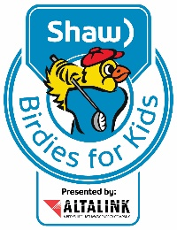
Literacy for Life is excited to be a participating charity in the Shaw Birdies for Kids presented by AltaLink. This gives us the opportunity to have all money raised through the Grate Groan Up Spelling Bee matched up to 50%! Let’s work together to make this our most successful year yet! Funds must be in by September 1st 2019

Please mail $50.00 Registration fee to:
Pre-purchase Mulligans today!
☐1 for $25.00
☐2 for $50.00
☐3 for $100.00
(Please include payment with Registration Fee)
Literacy for Life Foundation
#3, 1204 10th Street SE
High River, AB
T1V 2B9

You are the Bees Knees! Thank you for considering entering a team in the Grate Groan Up Spelling Bee!

In the Hive News! BEEE Aware!

This is Literacy for Life’s signature Fund Raiser!
Ways you can help make it the Gratest Bee ever!

- Register your Team early and start your fundraising:
- Literacy for Life is excited to be a participating charity in the Shaw Birdies for Kids presented by AltaLink. This gives us the opportunity to have all money raised through the Grate Groan Up Spelling Bee matched up to 50%
- This includes Registration Fee, Mulligans, Sponsorships Donations and raffle sales.
- Funds must be submitted to Literacy for Life by September 1st, 2019 to be matched through the Shaw Birdies for Kids Presented by AltaLink Program.
- Continue to collect donations and sell raffle tickets right up to September 28th 2019!

- We are asking each team member to sell at least one book of raffle tickets. (Tickets available April 1st, 2019) The office will contact your team lead to distribute to other members.

- Spread the word through your business and personal social media and other networks. Encourage them to donate and to attend the Bee! Remember you will never get donations if you don’t ask.

- Set up fun photo shoots and opportunities for people to support your team in collecting the Gratest Pledges.
- FaceBook Birthday Fundraiser
- Share pictures and events of your team with Literacy for Life and we will promote on LFL’s Social media
Facebook: https://www.facebook.com/LiteracyforLife
Twitter: https://twitter.com/FoothillsLFL
Instagram: https://www.instagram.com/literacyforlifefoundation/
- Have a party or event and ask people to bring a donation in support of literacy
- Set up an opportunity at your business for individuals to donate

